Senator Harriette L. Chandler
MASSACHUSETTS SENATE
First Worcester -- Consisting of the towns of Boylston, Clinton, precincts 3 and 4, Holden, Northborough, precincts 1, 2 and 4, Princeton and West Boylston, and the city of Worcester, wards 1 to 4, inclusive, ward 8, precincts 2 to 4, inclusive, and wards 9 and 10 in the county of Worcester.
Harriette.Chandler@masenate.gov
24 Beacon St.
Room 333
Boston, MA, 02133
Phone:
(617) 722-1544
No District Office

Senator Joanne M. Comerford

Hampshire, Franklin and Worcester -- Consisting of the city of Northampton and the towns of Amherst, Hadley, Hatfield, Pelham and South Hadley in the county of Hampshire; the towns of Bernardston, Colrain, Deerfield, Erving, Gill, Greenfield, Leverett, Leyden, Montague, New Salem, Northfield, Orange, Shutesbury, Sunderland, Warwick, Wendell and Whately in the county of Franklin; and the town of Royalston in the county of Worcester.
Jo.Comerford@masenate.gov

State House
24 Beacon St.
Room 413-C
Boston, MA, 02133
Phone:
(617) 722-1532

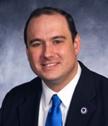Senator James B. Eldridge
Middlesex and Worcester -- Consisting of the city of Marlborough and the towns of Acton, Ayer, Boxborough, Hudson, Littleton, Maynard, Shirley, Stow and Sudbury, precincts 2 and 3 all in the county of Middlesex; and the towns of Harvard, Northborough, precinct 3, Southborough and Westborough, all in the county of Worcester.

James.Eldridge@masenate.gov

24 Beacon St.
Room 511-C
Boston, MA, 02133
Phone:
(617) 722-1120

District Office:
255 Main Street
Marlborough, MA 01752

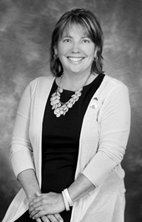Senator Anne M. Gobi
Worcester, Hampden, Hampshire and Middlesex - Consisting of the towns of Ashburnham, Athol, Barre, Brookfield, Charlton, East Brookfield, Hardwick, Hubbardston, New Braintree, North Brookfield, Oakham, Paxton, Petersham, Phillipston, Rutland, Spencer, Sturbridge, Templeton, Warren, West Brookfield and Winchendon in the county of Worcester; the towns of Brimfield, Holland, Monson, Palmer and Wales in the county of Hampden; the town of Ware in the county of Hampshire; and the town of Ashby in the county of Middlesex.
anne.gobi@masenate.gov
State House
24 Beacon St.
Room 513
Boston, MA, 02133
Phone:
(617) 722-1540

Senator Adam G. Hinds
Berkshire, Hampshire, Franklin and Hampden -- Consisting of the cities and towns in the county of Berkshire; the towns of Chesterfield, Cummington, Goshen, Huntington, Middlefield, Plainfield, Westhampton, Williamsburg and Worthington in the county of Hampshire; and the towns of Ashfield, Buckland, Charlemont, Conway, Hawley, Heath, Monroe, Rowe and Shelburne in the county of Franklin; and the towns of Blandford and Chester in the county of Hampden.
adam.hinds@masenate.gov
State House
24 Beacon St.
Room 109-E
Boston, MA, 02133
Phone:
(617) 722-1625
District Office
100 North Street
Suite 410
Pittsfield, MA 01201
Phone:
(413)344-4561 or (413)768-2373

Senator John Velis
Second Hampden and Hampshire -- Consisting of the cities of Chicopee, ward 7, precincts A and B, ward 8, precinct A, ward 9, precinct A, Holyoke and Westfield and the towns of Agawam, Granville, Montgomery, Russell, Southwick and Tolland, in the county of Hampden; and the towns of Easthampton and Southampton in the county of Hampshire.
john.velis@masenate.gov
State House
24 Beacon St.
Room 313-A
Boston, MA, 02133
Phone:
(617) 722-1415

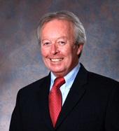Senator Edward J. Kennedy
First Middlesex -- Consisting of the city of Lowell and the towns of Dunstable, Groton, Pepperell, Tyngsborough and Westford in the county of Middlesex.

edward.kennedy@masenate.gov

24 Beacon St.
Room 405
Boston, MA, 02133
Phone:
(617) 722-1630

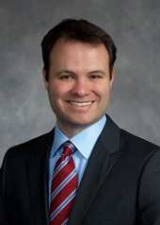Senator Eric P. Lesser
First Hampden and Hampshire -- Consisting of the cities of Chicopee, ward 1, precincts A and B, ward 5, precincts A and B, ward 6, precincts A and B, ward 8, precinct B and ward 9, precinct B and Springfield, ward 2, precinct G, ward 4, precinct F, ward 5, precincts D, F, G and H, ward 6, precincts B, D and H, ward 7 and ward 8, precinct A and the towns of East Longmeadow, Hampden, Longmeadow, Ludlow and Wilbraham in the county of Hampden; and the towns of Belchertown and Granby in the county of Hampshire.
eric.lesser@masenate.gov

State House
24 Beacon St.
Room 413-C
Boston, MA, 02133
Phone: (617) 722-1291

District Office
60 Shaker Road
Unit 3B
East Longmeadow, MA 01028
Phone: 413-526-6501

Senator Michael O. Moore

Second Worcester -- Consisting of the towns of Auburn, Grafton, Leicester, Millbury, Northbridge, precincts 2 and 4, Shrewsbury and Upton and the city of Worcester, wards 5 to 7, inclusive, and ward 8, precincts 1 and 5 in the county of Worcester.
Michael.Moore@masenate.gov
State House
24 Beacon St.
Room 109-B
Boston, MA, 02133
Phone: (617) 722-1485
District Office
36 North Quinsigamond Avenue
Shrewsbury, MA 01545
Phone: (508) 757-0323 x 13

Senator John Cronin
Worcester and Middlesex -- Consisting of the cities of Fitchburg, Gardner and Leominster and the towns of Berlin, Bolton, Clinton, precincts 1 and 2, Lancaster, Lunenburg, Sterling and Westminster in the county of Worcester; and the town of Townsend in the county of Middlesex.
John.Cronin@masenate.gov
State House
24 Beacon St.
Room 504
Boston, MA, 02133
Phone: (617) 722-1230

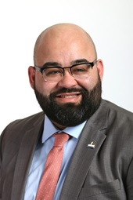Senator Adam Gomez
Hampden -- Consisting of the cities of Chicopee, ward 2, precincts A and B, ward 3, precincts A and B, ward 4, precincts A and B, and Springfield, ward 1, ward 2 precincts A to F, inclusive, and H, ward 3, ward 4, precincts A to E, inclusive, G and H, ward 5, precincts A to C, inclusive, and E, ward 6, precincts A and C, and E to G, inclusive, ward 8, precincts B to H, inclusive, and the town of West Springfield in the county of Hampden.
Adam.Gomez@masenate.gov
State House
24 Beacon St.
Room 413-B
Boston, MA, 02133
Phone: (617) 722-1660

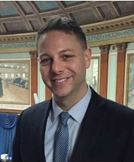Representative James Arciero
MASSACHUSETTS
HOUSE OF REPRESENTATIVES

Second Middlesex, Consisting of Chelmsford: Precincts 5, 7, 8; Littleton; Westford.
James.Arciero@mahouse.gov
State House
24 Beacon St.
Room 277
Boston, MA, 02133
Phone: (617) 722-2012
__________________________________________________

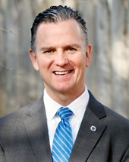Representative Brian M. Ashe
Second Hampden, Consisting of East Longmeadow: Precincts 2, 3, 4; Hampden; Longmeadow; Monson.
Brian.Ashe@mahouse.gov

State House
24 Beacon St. Room 236
Boston, MA, 02133 Phone: (617) 722-2430
District Office Phone: (413) 754-4184

Representative John Barrett
First Berkshire, Consisting of Adams; Cheshire; Clarksburg; Florida; Hancock; Lanesborough; New Ashford; North Adams; Williamstown.
john.barrett@mahouse.gov
State House
24 Beacon St.
Room 237
Boston, MA, 02133
Phone:
(617) 722-2305
District Office
8 Park St.
Adams, MA 01220
Phone:
(413) 743-8300

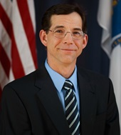Representative Donald Berthiaume
Fifth Worcester, Consisting of Barre; Brookfield; East Brookfield; Hardwick; Hubbardston; New Braintree; North Brookfield; Oakham; Spencer: Precincts 2, 3, 4; West Brookfield; Ware: Precinct A (Hampshire Co.)
Donald.Berthiaume@mahouse.gov
State House
24 Beacon St.
Room 540
Boston, MA, 02133
Phone:
(617) 722-2090
__________________________________________________

Representative Natalie Blais
First Franklin, Consisting of Ashfield; Buckland; Conway; Deerfield; Leverett; Montague; Shelburne; Shutesbury; Sunderland; Whately; Chester (Hampden Co.); Chesterfield (Hampshire Co.); Cummington (Hampshire Co); Goshen (Hampshire Co); Huntington (Hampshire Co.); Middlefield (Hampshire Co); Plainfield (Hampshire Co.); Williamsburg (Hampshire Co.); Worthington (Hampshire Co.)
Natalie.Blais@mahouse.gov
State House

24 Beacon St.
Room 134
Boston, MA, 02133
Phone:
(617) 722-2400

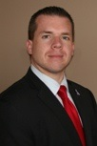Representative Nicholas Boldyga
Third Hampden, Consisting of Agawam; Granville; Southwick.
Nicholas.Boldyga@mahouse.gov
24 Beacon St.
Room 167
Boston, MA, 02133
Phone:
(617) 722-2810
Fax:
617-626-0137
District Office
Town Hall
454 College Highway
Southwick, MA 01077
Phone:
(413) 569-3137 Ext 103
Fax:
413- 455-3180

Representative Daniel Carey
Second Hampshire, Consisting of Easthampton; Granby: Precinct 2; Hadley; South Hadley
daniel.carey@mahouse.gov
24 Beacon St.
Room 33
Boston, MA, 02133
Phone:
(617) 722-2060

Representative Mindy Domb
Third Hampshire, Consisting of Amherst; Granby: Precinct 1; Pelham
mindy.domb@mahouse.gov
24 Beacon St.
Room 134
Boston, MA, 02133
Phone:
(617) 722-2400
District Office
PO Box 3215
Amherst, MA 01004-3215
Phone:
(413) 461-2060

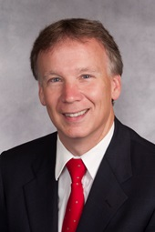 Representative Peter Durant
Sixth Worcester, Consisting of Charlton: Precincts 1, 2, 3; Dudley; Southbridge; Spencer: Precinct 1.
Peter.Durant@mahouse.gov

24 Beacon St.
Room 33
Boston, MA, 02133
Phone:
(617) 722-2060

Representative Carolyn Dykema
Eighth Middlesex, Consisting of Holliston; Hopkinton; Southborough (Worcester Co.); Westborough: Precinct 2 (Worcester Co.).
Carolyn.Dykema@mahouse.gov

24 Beacon St.
Room 127
Boston, MA, 02133
Phone:
(617) 722-2680
Fax:
617-722-2239

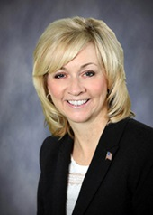 Representative Kimberly Ferguson
First Worcester, Consisting of Holden; Paxton, Princeton; Rutland; Sterling: Precinct 1; Westminster: Precinct 2.
Kimberly.Ferguson@mahouse.gov

24 Beacon St.
Room 473B
Boston, MA, 02133
Phone:
(617) 722-2263
Fax:
617-626-0182

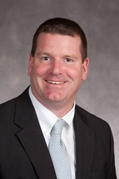 Representative Michael Finn
Sixth Hampden, Consisting of Chicopee: Ward 2: Precinct A, Ward 3: Precinct A, Ward 4: Precinct A; Springfield: Ward 2: Precinct E; West Springfield.
Michael.Finn@mahouse.gov

24 Beacon St.
Room 274
Boston, MA, 02133
Phone:
(617) 722-2676
Fax:
617-626-0189
District Office
71 Park Avenue
West Springfield, MA 01089
Phone:
413-363-1965

Representative Paul Frost
Seventh Worcester, Consisting of Auburn; Charlton: Precinct 4; Millbury; Oxford: Precincts 2, 3.
Paul.Frost@mahouse.gov

24 Beacon St.
Room 542
Boston, MA, 02133
Phone:
(617) 722-2489

Representative Michael Kushmerek
Third Worcester, Consisting of Fitchburg; Lunenburg: Precinct B.

Michael.Kushmerek@mahouse.gov
24 Beacon St.
Boston, MA, 02133
Phone:
(617) 722-2800

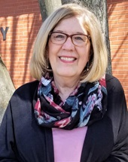Representative Kate Hogan
Third Middlesex, Consisting of Hudson; Maynard; Stow; Bolton (Worcester Co.).
Kate.Hogan@mahouse.gov

24 Beacon St.
Room 370
Boston, MA, 02133
Phone:
(617) 722-2600

Representative Natalie Higgins
Fourth Worcester, Consisting of Leominster
Natalie.Higgins@mahouse.gov

24 Beacon St.
Room 527A
Boston, MA, 02133
Phone:
(617) 722-2020
District Office
24 Church Street, Room 29
Leominster, MA 01453
Phone:
(978) 227-5278

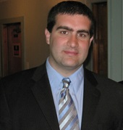Representative Paul Mark
Second Berkshire, Consisting of Dalton; Hinsdale; Peru; Pittsfield: Ward 1: Precinct B; Savoy; Windsor; Bernardston (Franklin Co.); Charlemont (Franklin Co.); Colrain (Franklin Co.); Greenfield (Franklin Co.); Hawley (Franklin Co.); Heath (Franklin Co.); Leyden (Franklin Co.); Monroe (Franklin Co.); Northfield (Franklin Co.); Rowe (Franklin Co.).
Paul.Mark@mahouse.gov

24 Beacon St.
Room 160
Boston, MA, 02133
Phone:
(617) 722-2304
Fax:
617-626-0249
District Office
P.O. Box 114
Dalton, MA 01227
Phone:
413-464-5635

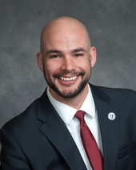Representative Joseph McKenna
Eighteenth Worcester, Consisting of Douglas; Oxford: Precincts 1, 4; Sutton; Webster.
joseph.mckenna@mahouse.gov

24 Beacon St.
Room 33
Boston, MA, 02133
Phone:
(617) 722-2060

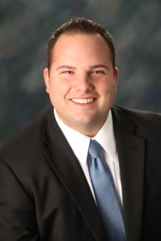Representative David Muradian
Ninth Worcester, Consisting of Grafton; Northbridge; Upton.
David.Muradian@mahouse.gov

24 Beacon St.
Room 156
Boston, MA, 02133
Phone:
(617) 722-2240

Representative Meghan Kilcoyne
Twelfth Worcester, Consisting of Berlin; Boylston; Clinton; Lancaster; Northborough: Precincts 2, 4; Sterling: Precinct 2
meghan.kilcoyne@mahouse.gov
24 Beacon St.
Room 167
Boston, MA, 02133
Phone:
(617) 722-2800

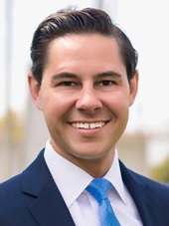Representative Jacob Oliveira
Seventh Hampden. - Consisting of Chicopee: Ward 6: Precinct B; Ludlow; Springfield: Ward 8: Precincts E, F, G; Belchertown: Precincts B, C, D (Hampshire Co.)
Jacob.Oliveira@mahouse.gov
24 Beacon St.
Room 146
Boston, MA, 02133
Phone:
(617) 722-2800

Representative Smitty Pignatelli
Fourth Berkshire, Consisting of Alford; Becket; Egremont; Great Barrington; Lee; Lenox; Monterey; Mount Washington; New Marlborough; Otis; Richmond; Sandisfield; Sheffield; Stockbridge; Tyringham; Washington; West Stockbridge; Blandford (Hampden Co.); Russell (Hampden Co.); Tolland (Hampden Co.).
rep.smitty@mahouse.gov

24 Beacon St.
Room 473F
Boston, MA, 02133
Phone:
(617) 722-2210
Fax:
617-722-2238
District Office
Lenox Town Hall
PO Box 2228
Lenox, MA 01240
Phone:
413-637-0631

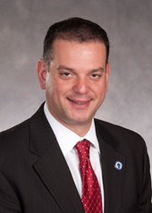Representative Angelo Puppolo
Twelfth Hampden, Consisting of East Longmeadow: Precinct 1; Springfield: Ward 6: Precincts C, D, G, H, Ward 7: Precincts B, C, D, E, G; Wilbraham
Angelo.Puppolo@mahouse.gov

24 Beacon St.
Room 122
Boston, MA, 02133
Phone:
(617) 722-2006
Fax:
617-722-2848
District Office
2341 Boston Road
Suite 204
Wilbraham, MA 01095
Phone:
413-596-4333

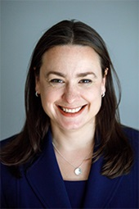Representative Lindsay Sabadosa
First Hampshire, Consisting of Hatfield; Northampton; Southampton; Westhampton; Montgomery (Hampden Co.).
lindsay.sabadosa@mahouse.gov

24 Beacon St.
Room 443
Boston, MA, 02133
Phone:
(617) 722-2460
District Office
76 Gothic St
Northampton, MA 01060
(413) 270-1166

Representative Danillo A. Sena
Thirty-seventh Middlesex, Consisting of Acton: Precincts 3, 4, 5; Ayer: Precinct 2; Boxborough; Shirley; Harvard (Worcester Co.); Lunenburg: Precincts A, C, D (Worcester Co.).
Danillo.Sena@mahouse.gov
24 Beacon St.
Room 39
Boston, MA, 02133
Phone:
(617) 722-2014

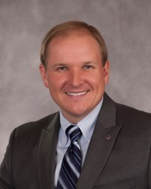Representative Todd Smola
First Hampden, Consisting of Brimfield; Holland; Palmer; Wales; Ware: Precincts B, C (Hampshire Co.); Sturbridge (Worcester Co.); Warren (Worcester Co.)
Todd.Smola@mahouse.gov

24 Beacon St.
Room 124
Boston, MA, 02133
Phone:
(617) 722-2100

Representative Patricia Duffy
Fifth Hampden, consisting of Holyoke
Patricia.Duffy@mahouse.gov

24 Beacon St.
Room 146
Boston, MA, 02133
Phone:
(617) 722-2800

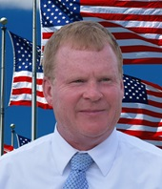Representative Kelly Pease
Fourth Hampden. - Consisting of the city of Westfield, in the county of Hampden. 52 Court Street Westfield 9 AM - 5 PM
Kelly.Pease@mahouse.gov

24 Beacon St.
Boston, MA, 02133
Phone:
(617) 722-2800

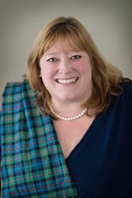Representative Susannah Whipps
Second Franklin, Consisting of Erving; Gill; New Salem; Orange; Warwick; Wendell; Belchertown: Precinct A (Hampshire Co.); Athol (Worcester Co.); Petersham (Worcester Co.); Phillipston (Worcester Co.); Royalston (Worcester Co.); Templeton (Worcester Co.).
Susannah.Whipps@mahouse.gov

24 Beacon St.
Room 540
Boston, MA, 02133
Phone:
(617) 722-2090

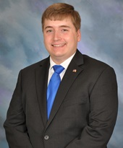Representative Jonathan Zlotnik
Second Worcester, consisting of Ashburnham; Gardner; Winchendon; Westminster: Precinct 1.

Jon.Zlotnik@mahouse.gov

24 Beacon St.
Room 26
Boston, MA, 02133
Phone:
(617) 722-2080
Fax:
617-626-0333
District Office
City Hall, Room 212
95 Pleasant Street
Gardner, MA 01440
Phone:
978-410-9559

